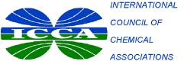

**[Name of National Association]**

**Declaration of Support for the ICCA Responsible Care® Global Charter**

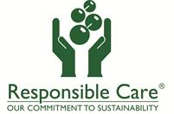

**[National Association] is committed to implementing the global chemical industry’s Responsible Care environmental, health, safety and security performance initiative, required by the ICCA Global Charter, and actively strengthening Responsible Care® worldwide.**

**Our Association expects our member companies, as well as our partners along the value chain, to safely manage the chemical products using a risk-based and life-cycle oriented approach, promote pollution prevention, minimization of waste and conservation of energy and other critical resources at every stage of the chemical product life cycle, while cooperating with national authorities and the community in accordance with our national Responsible Care programme.**

**By demonstrating this commitment, our Association is playing its part in actively safeguarding people and our environment, demonstrating our contribution to the UN Sustainable Development Goals, and enhancing our collective quality of life.**

**President Chief Executive Date**